USER STORY1

Navigated to Jenkins folder & started Jenkins on port 8080  
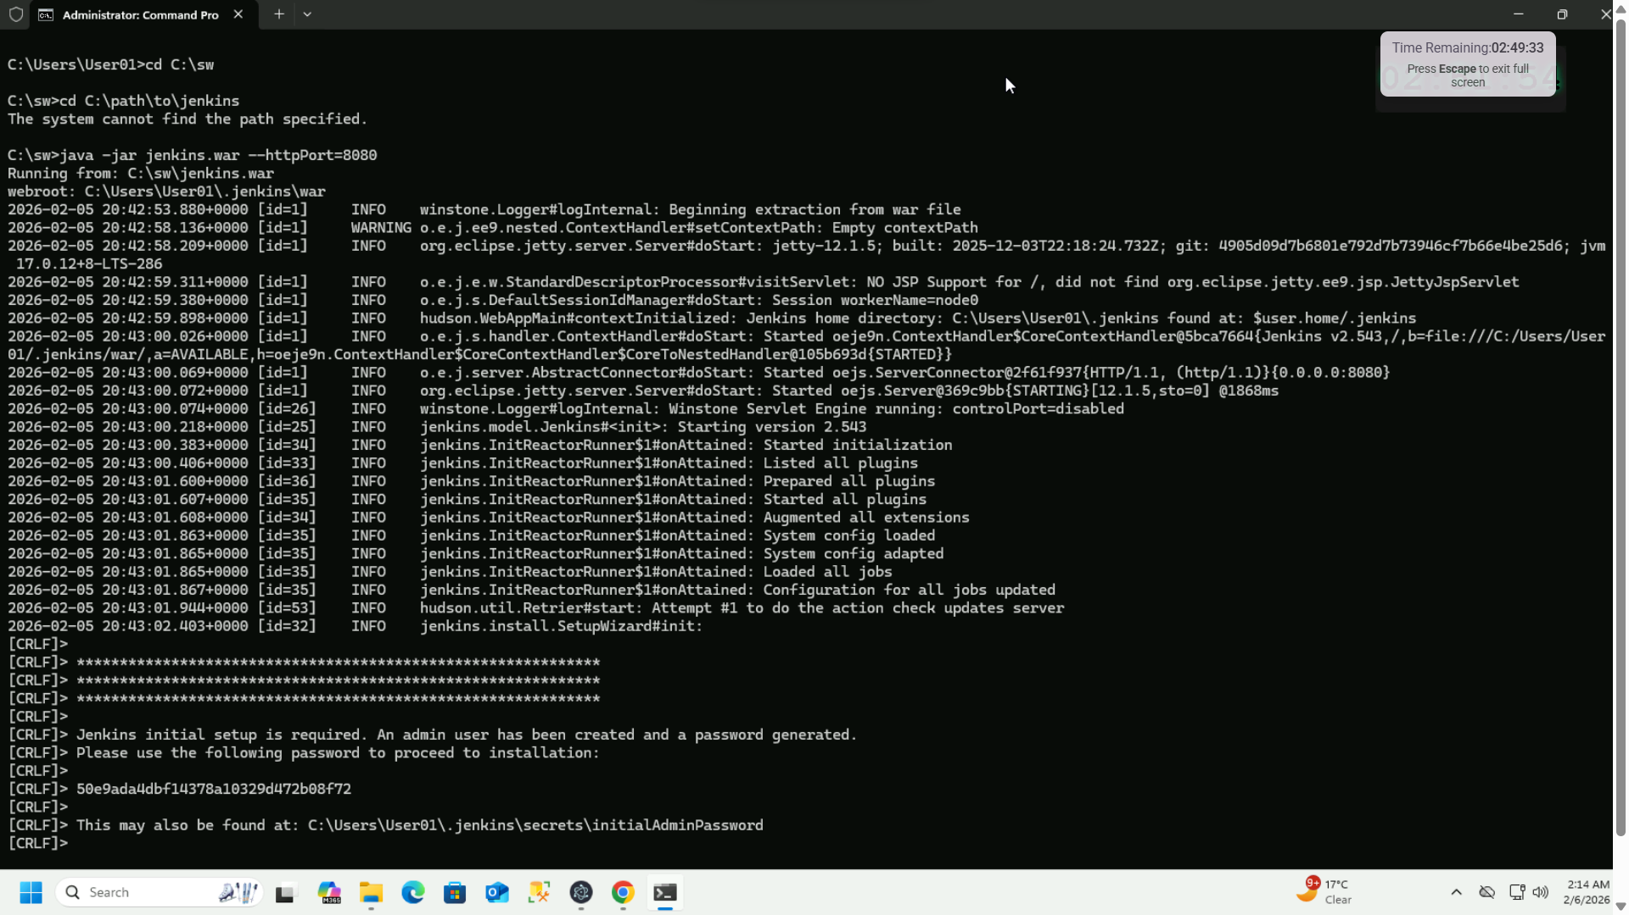  
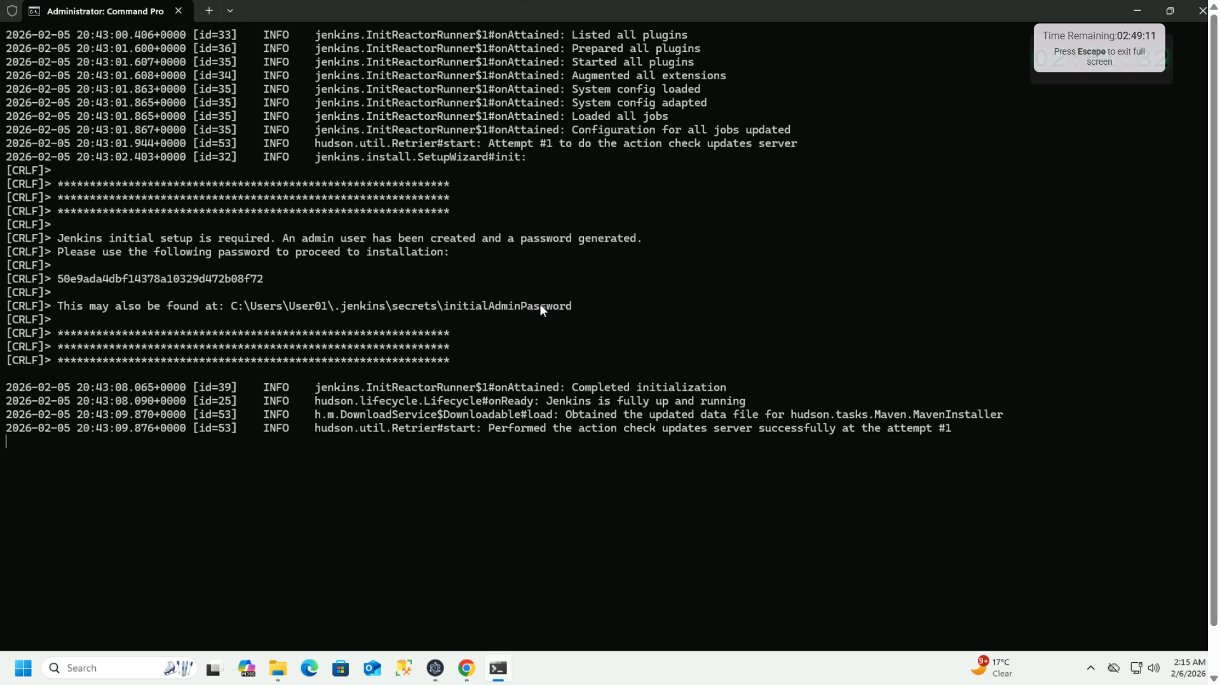

Jenkins running on localhost:8080  
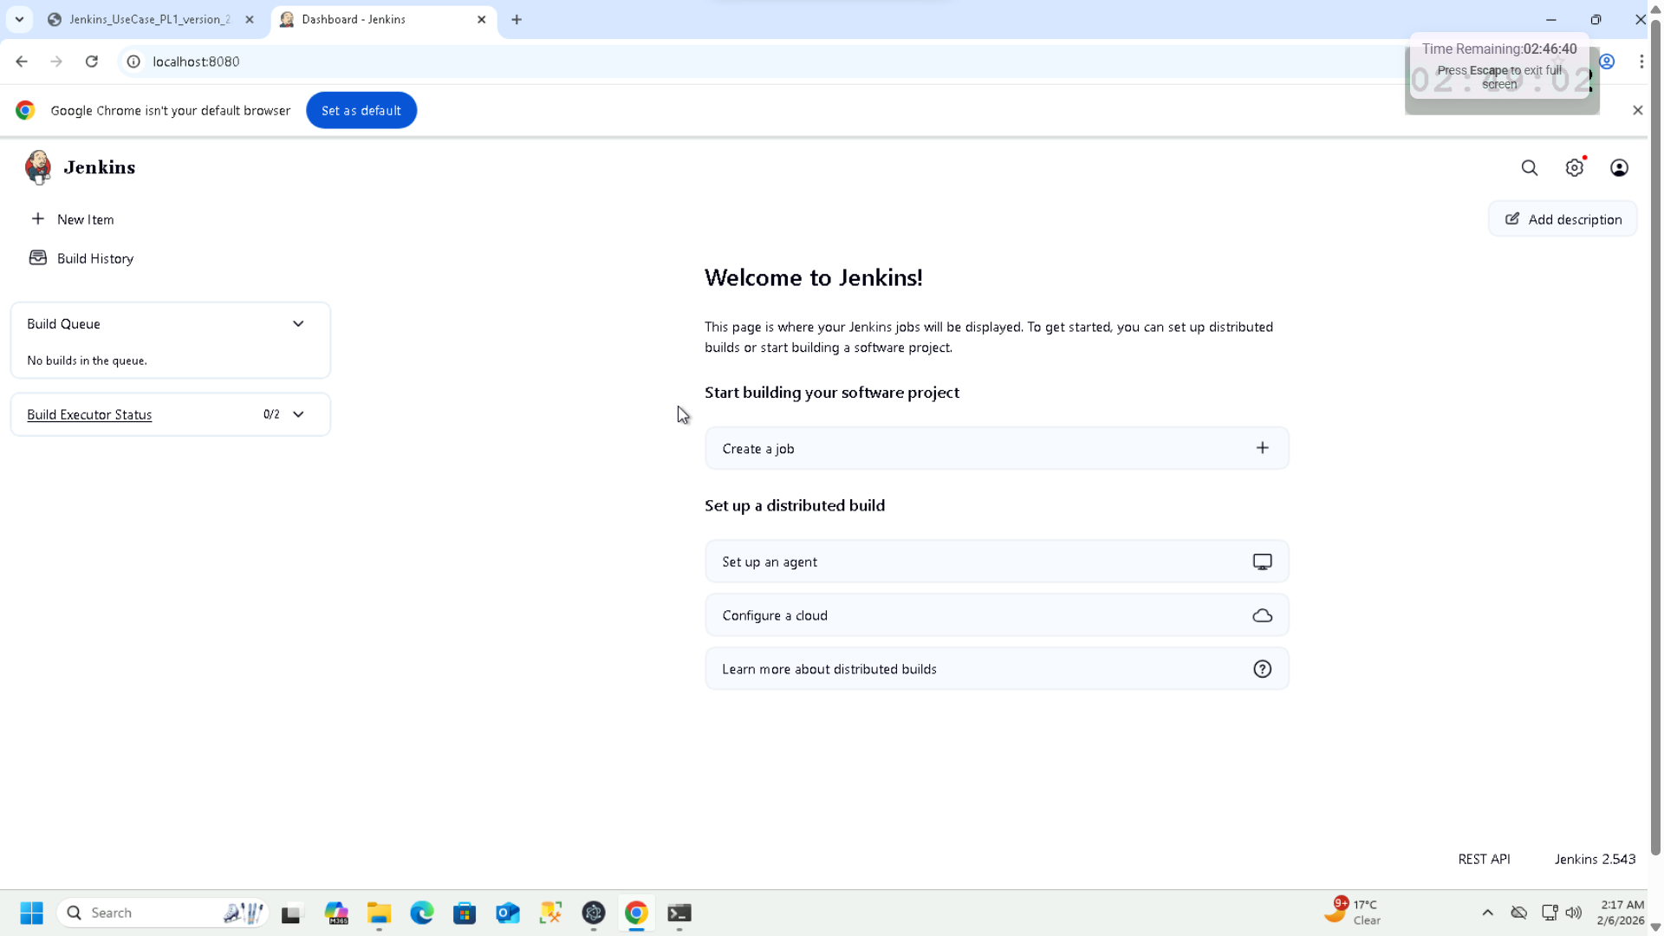

Jenkins -> Manage Jenkins -> Tools | Added JDK17 to Jenkins  
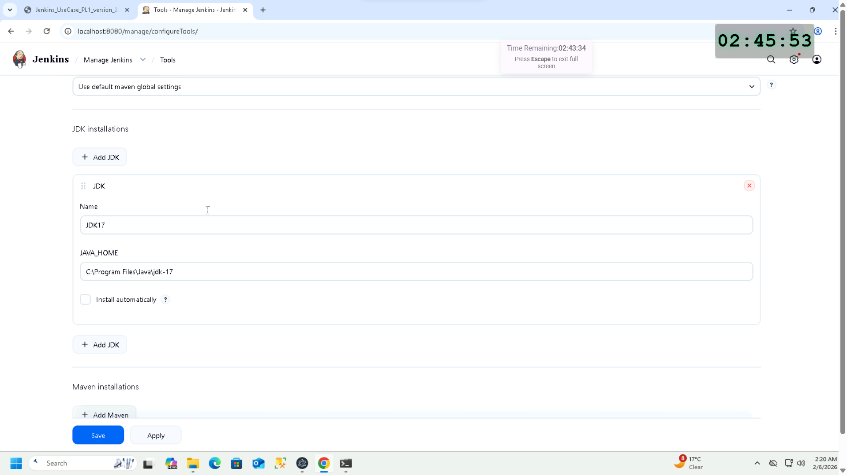

Installing Git plugin  
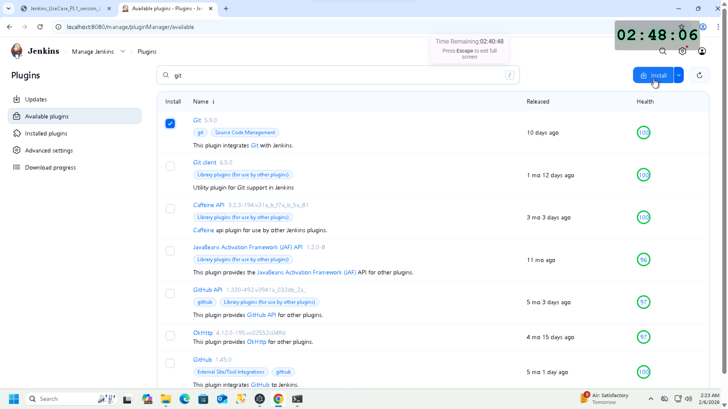  
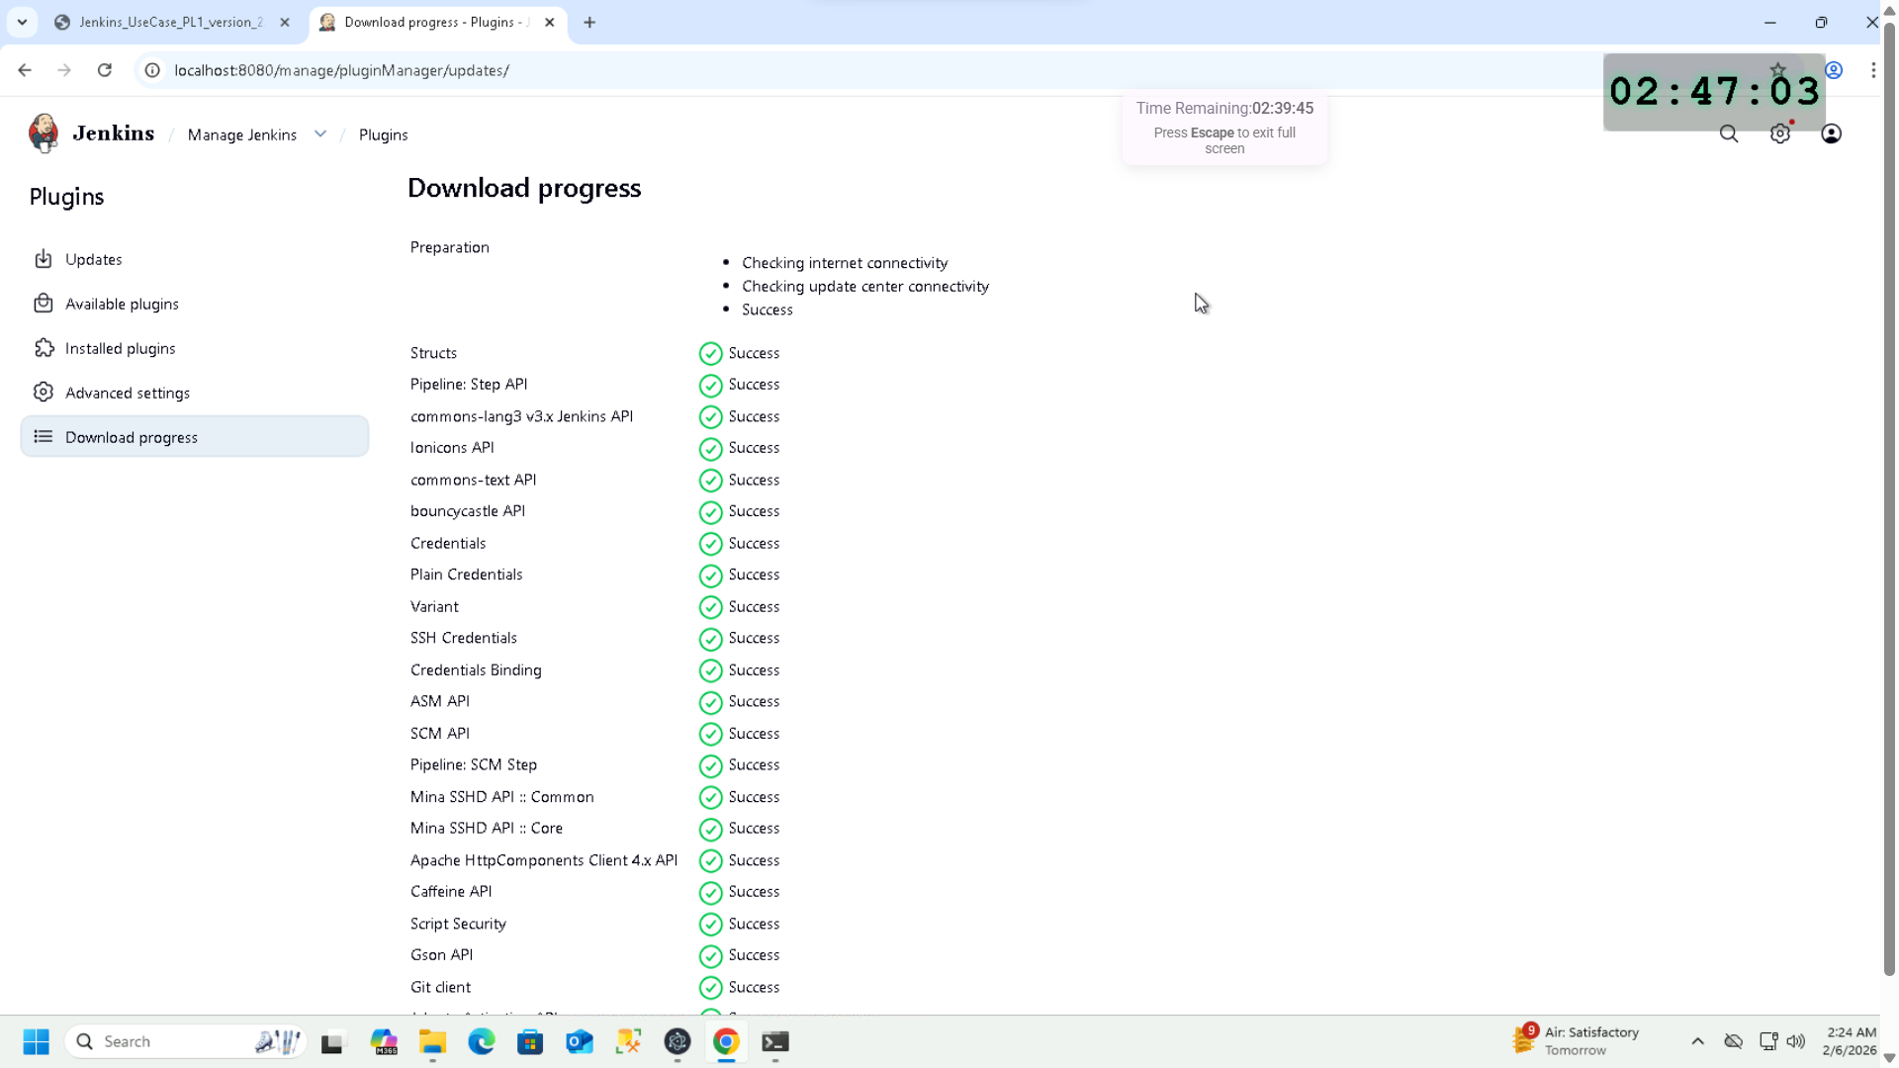

Added Git  
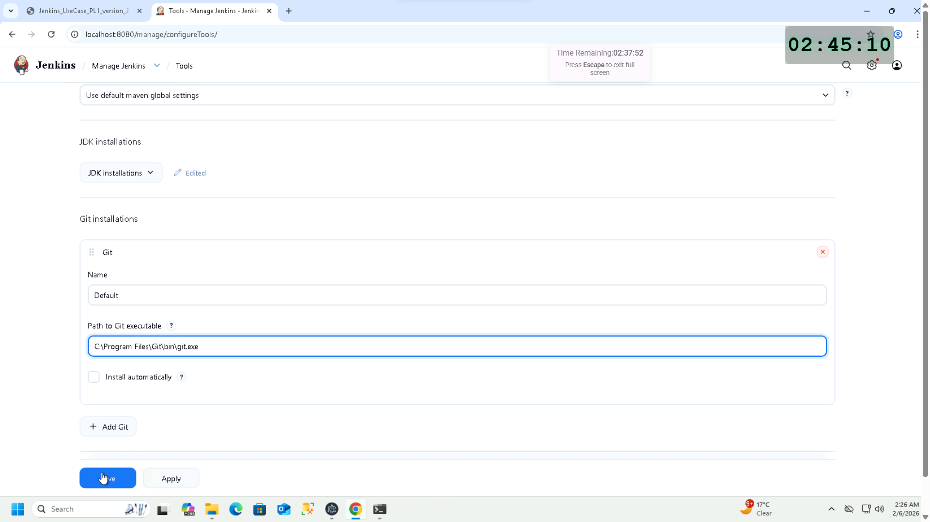

Junit plugin installed  
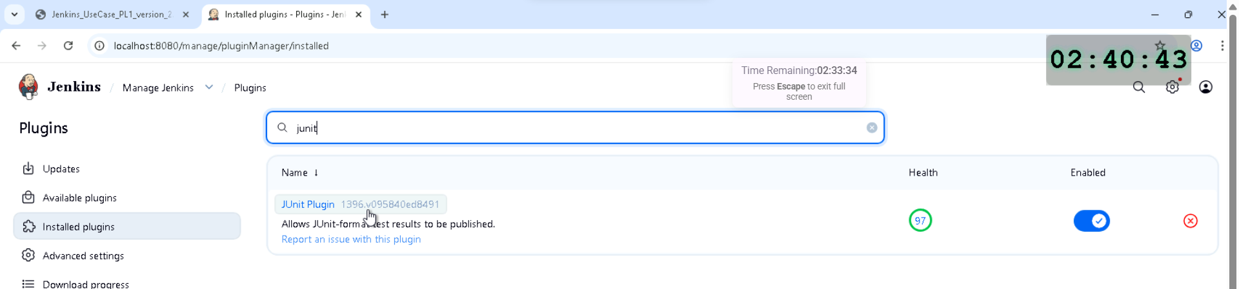

Email extension plugin installed  
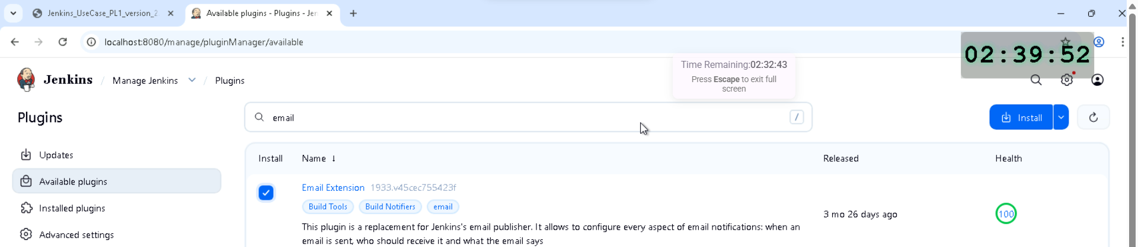  
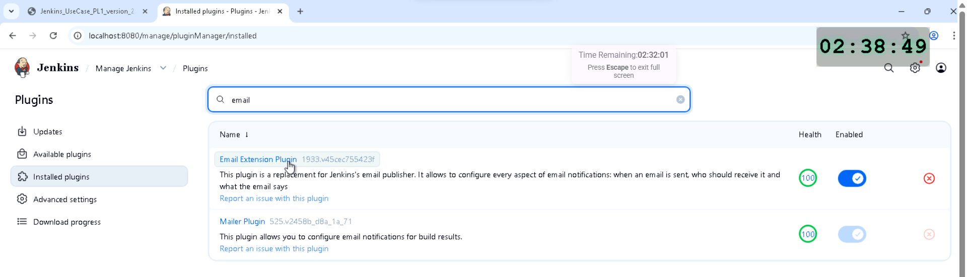

Email configuration – SMTP server & Authentication with credentials & Port  
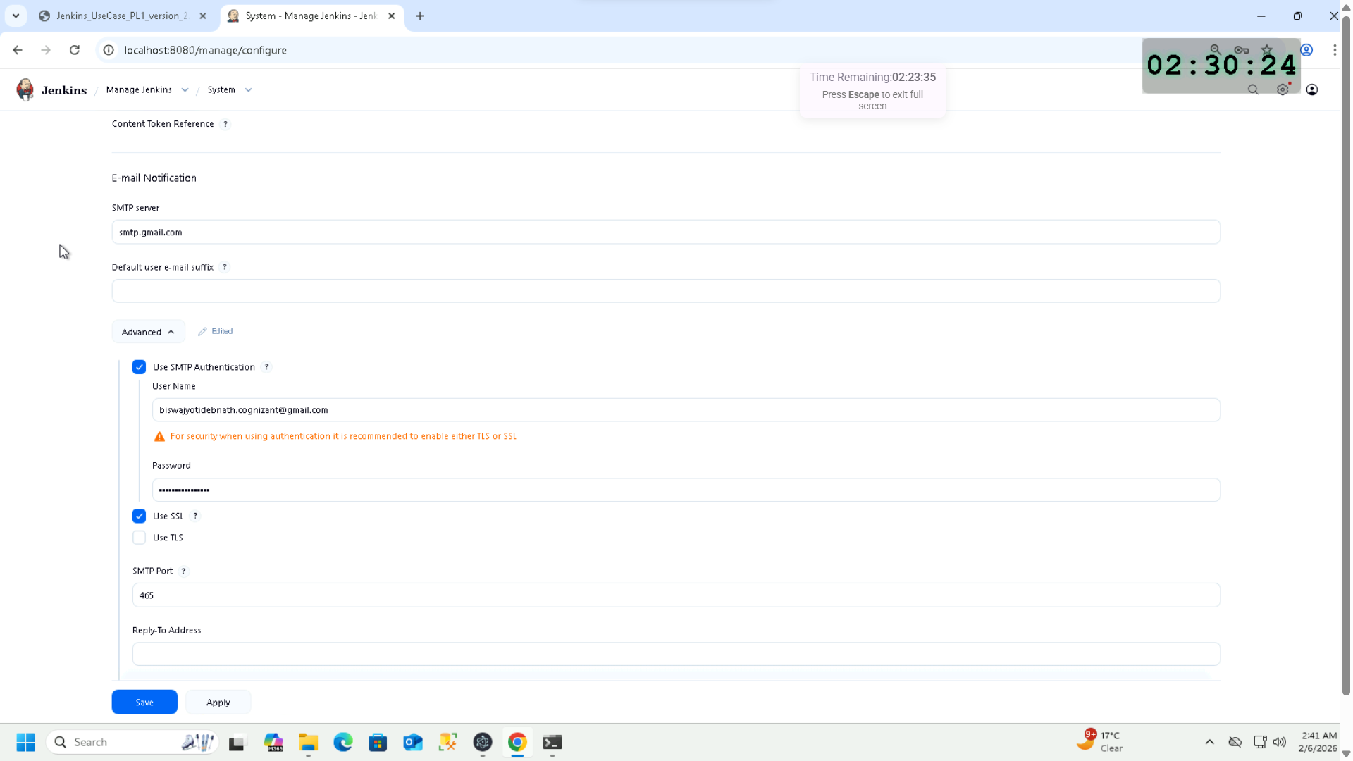

Default recipient added  
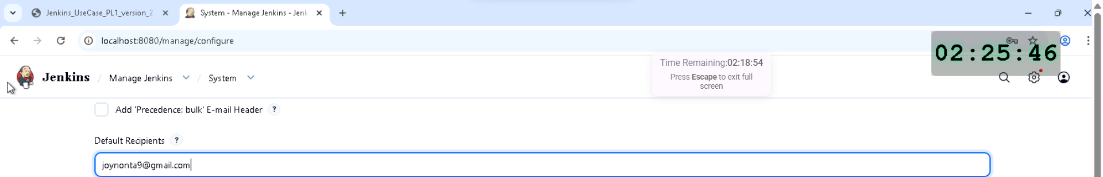

USER STORY 2

Creating freestyle job – (cannot use @ of my email for item name)  
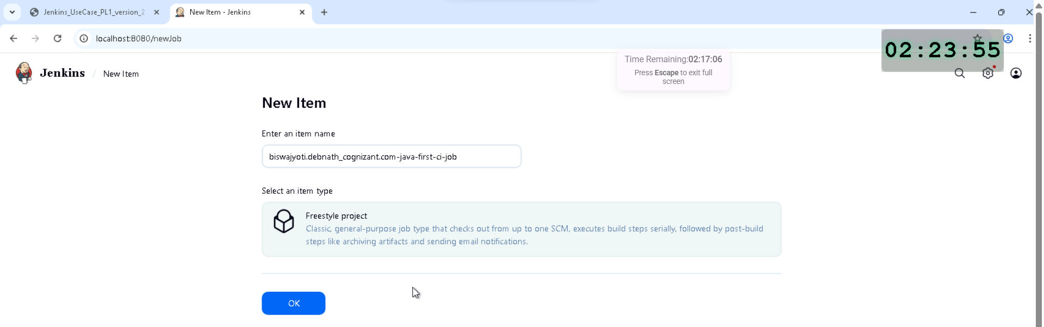

Github repo link & branch name added  
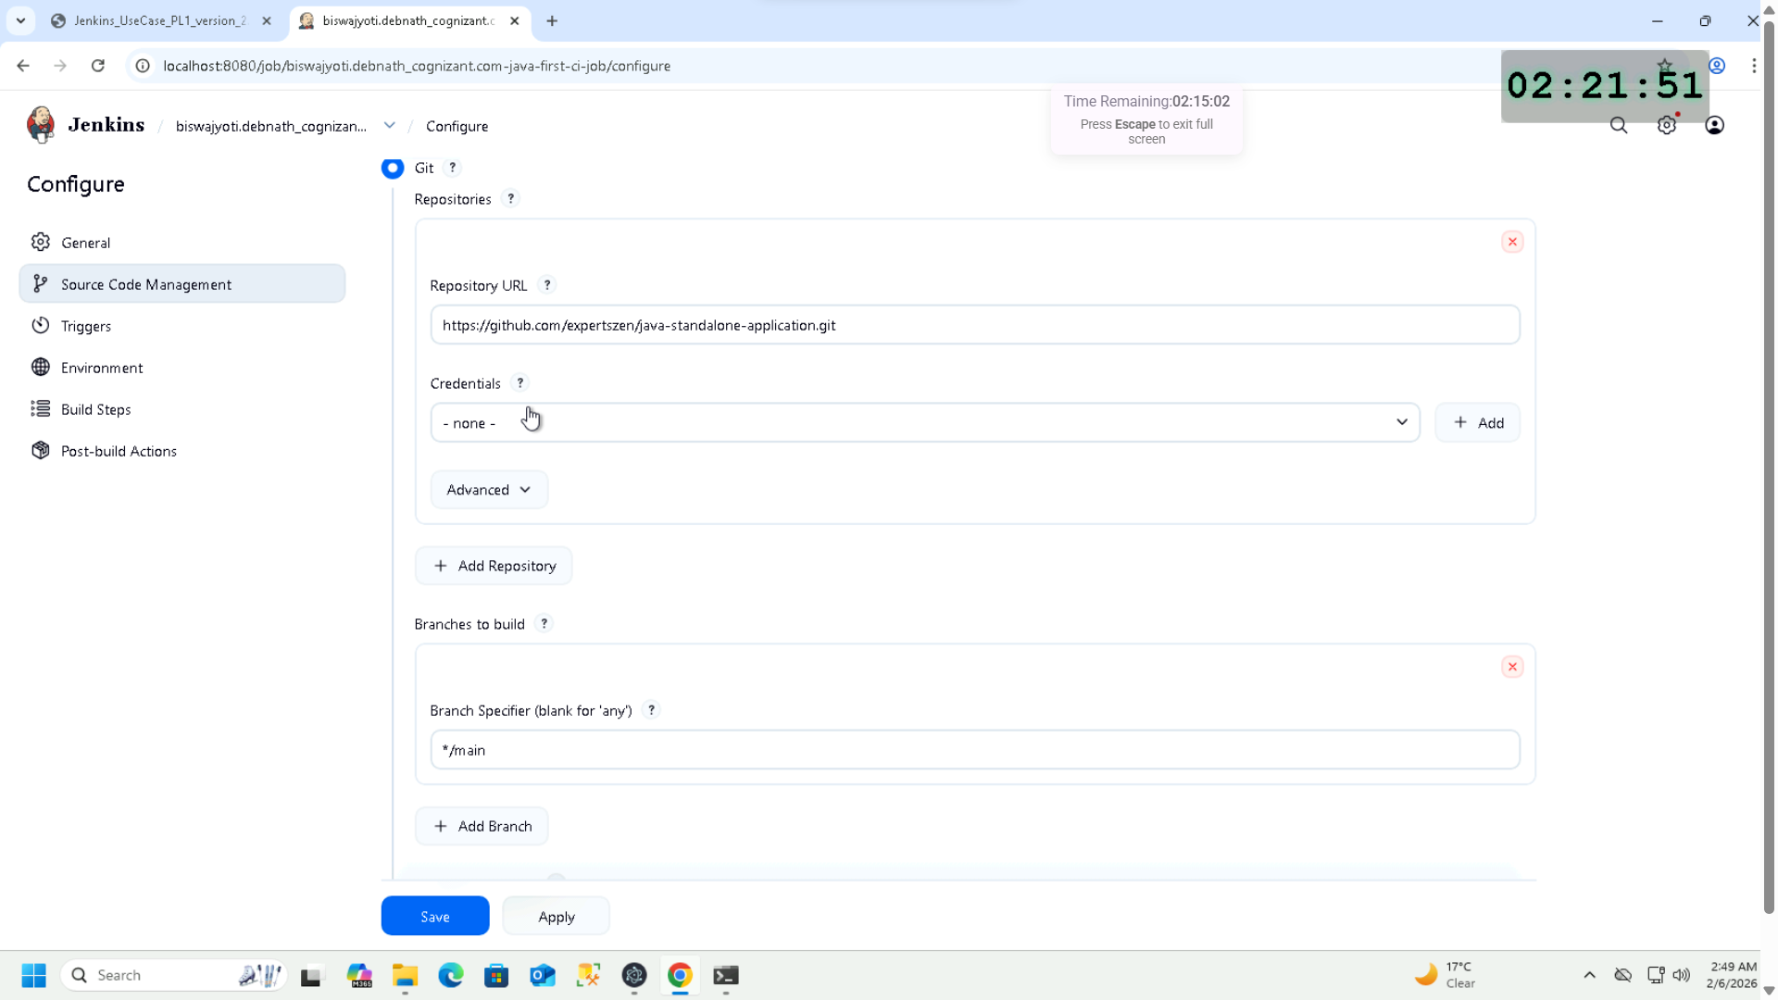

Maven configuration build step  
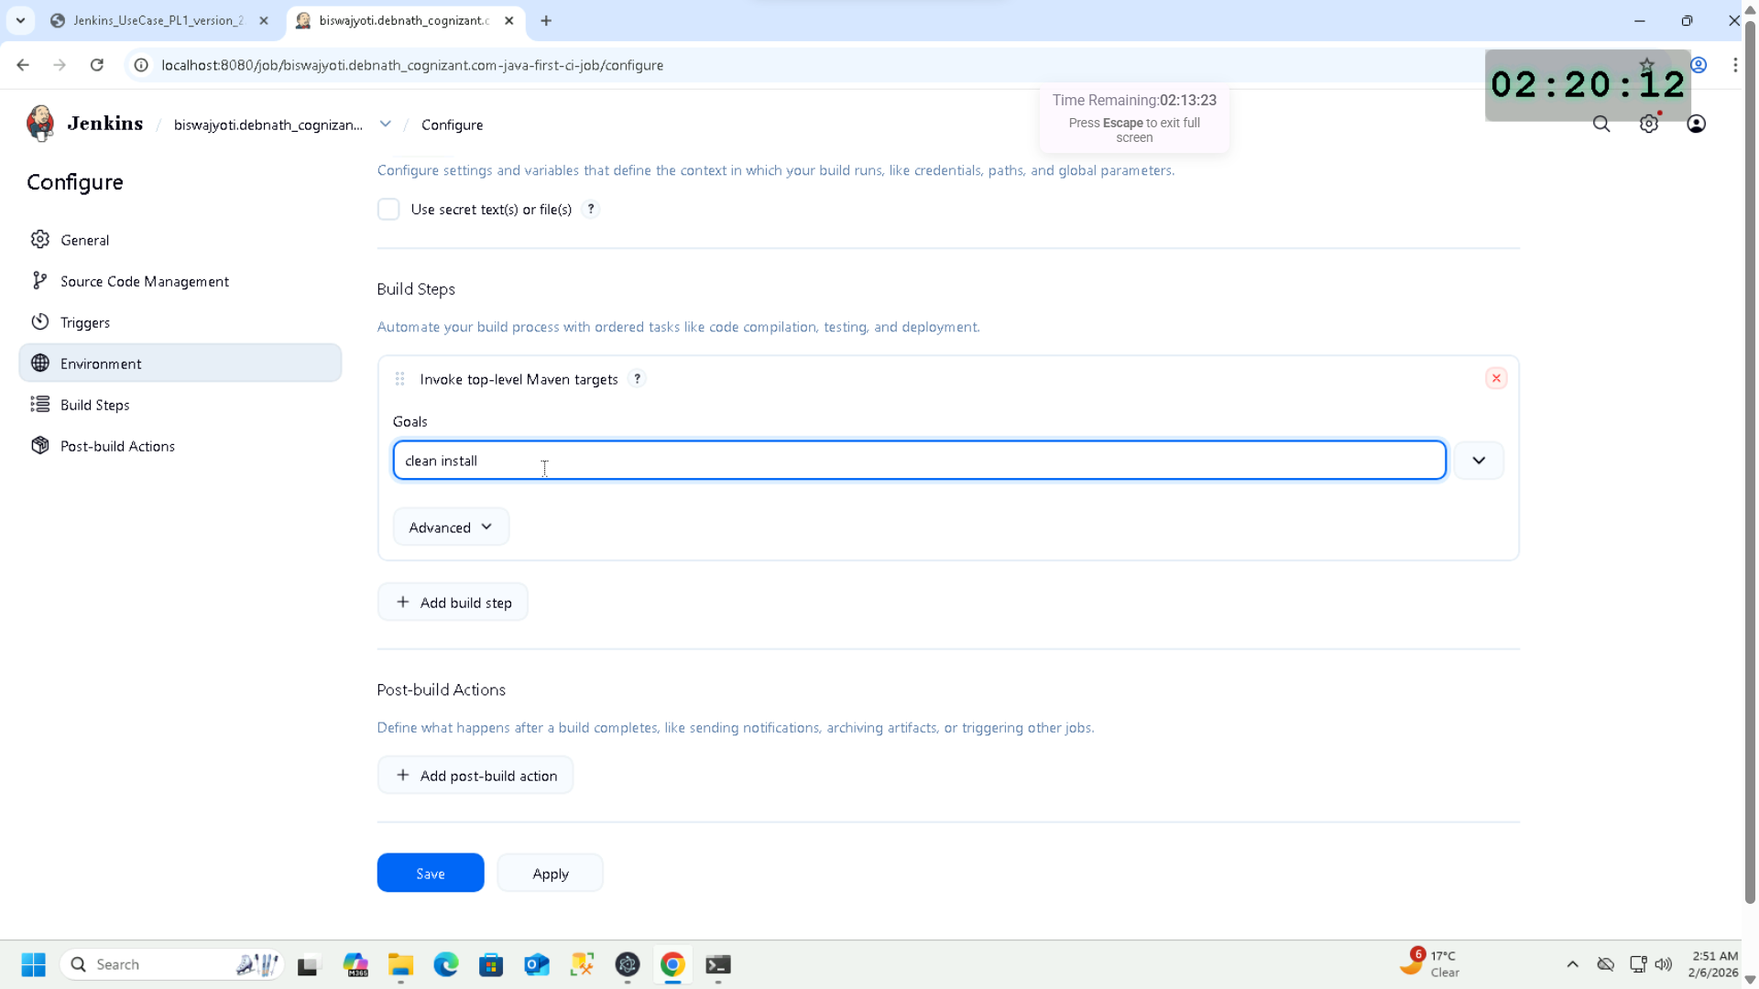

Post build action added with Junit publish report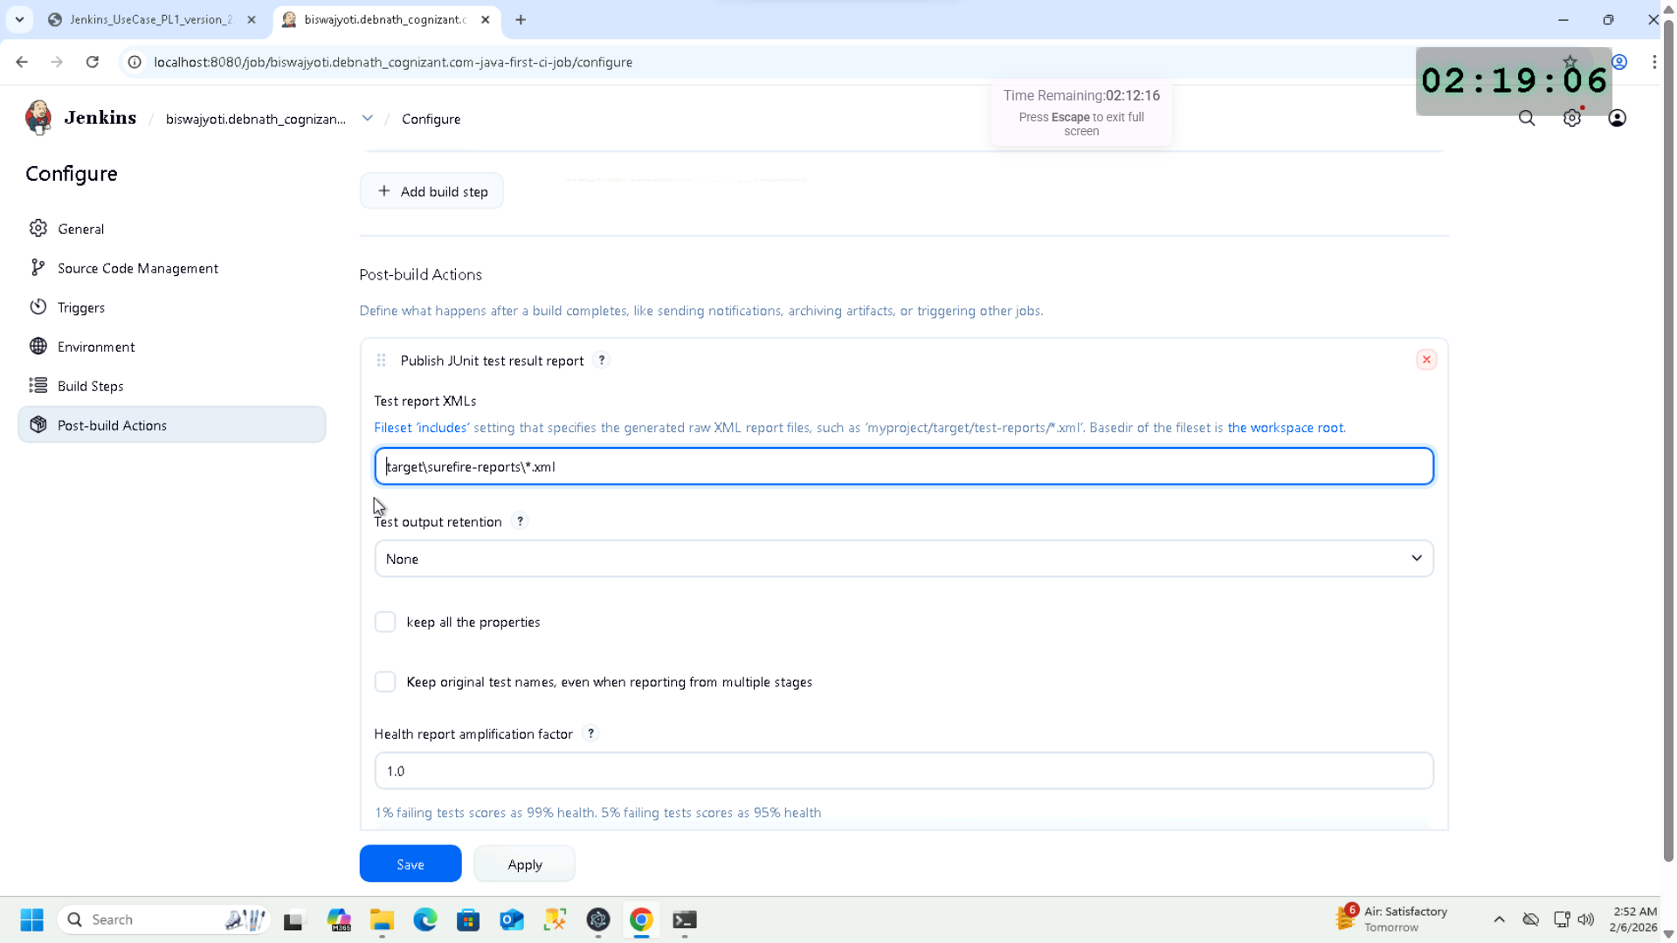

Job build successful  
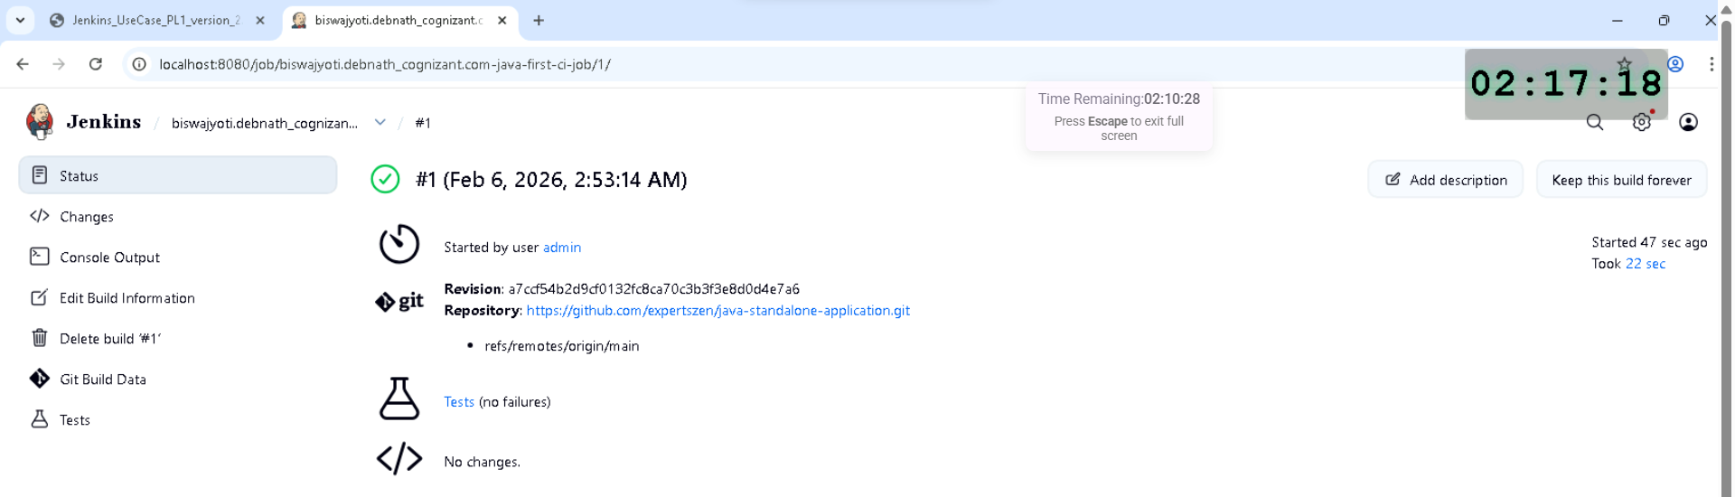

Console output  
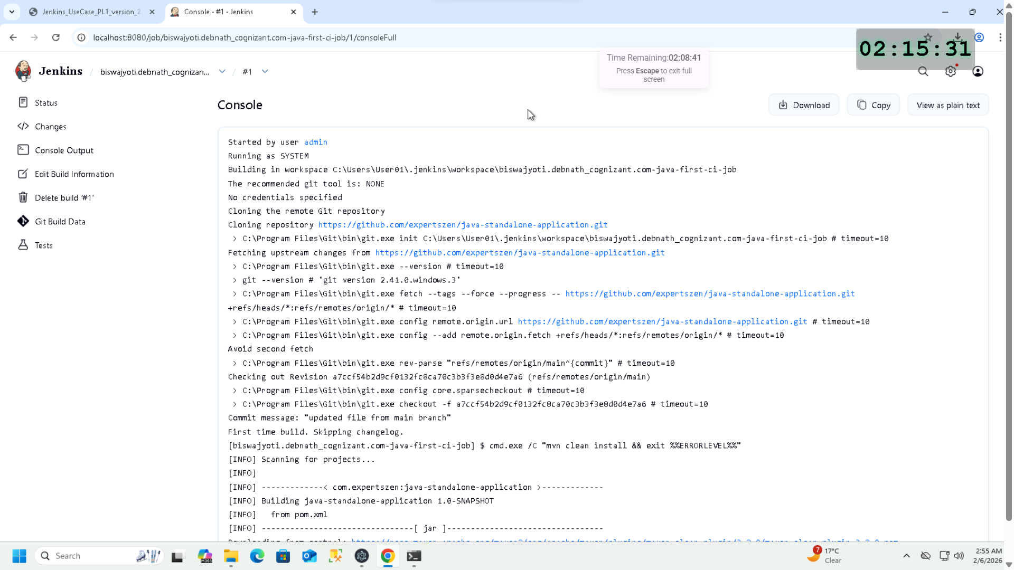  
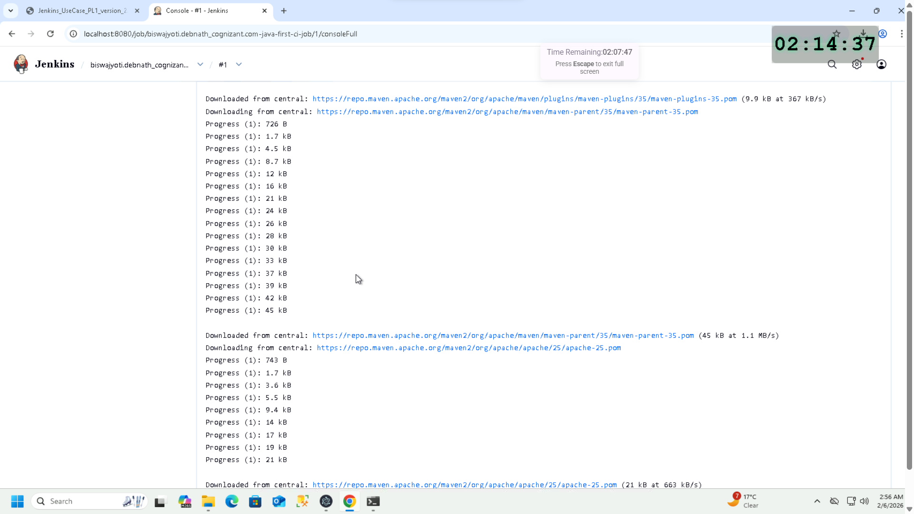  
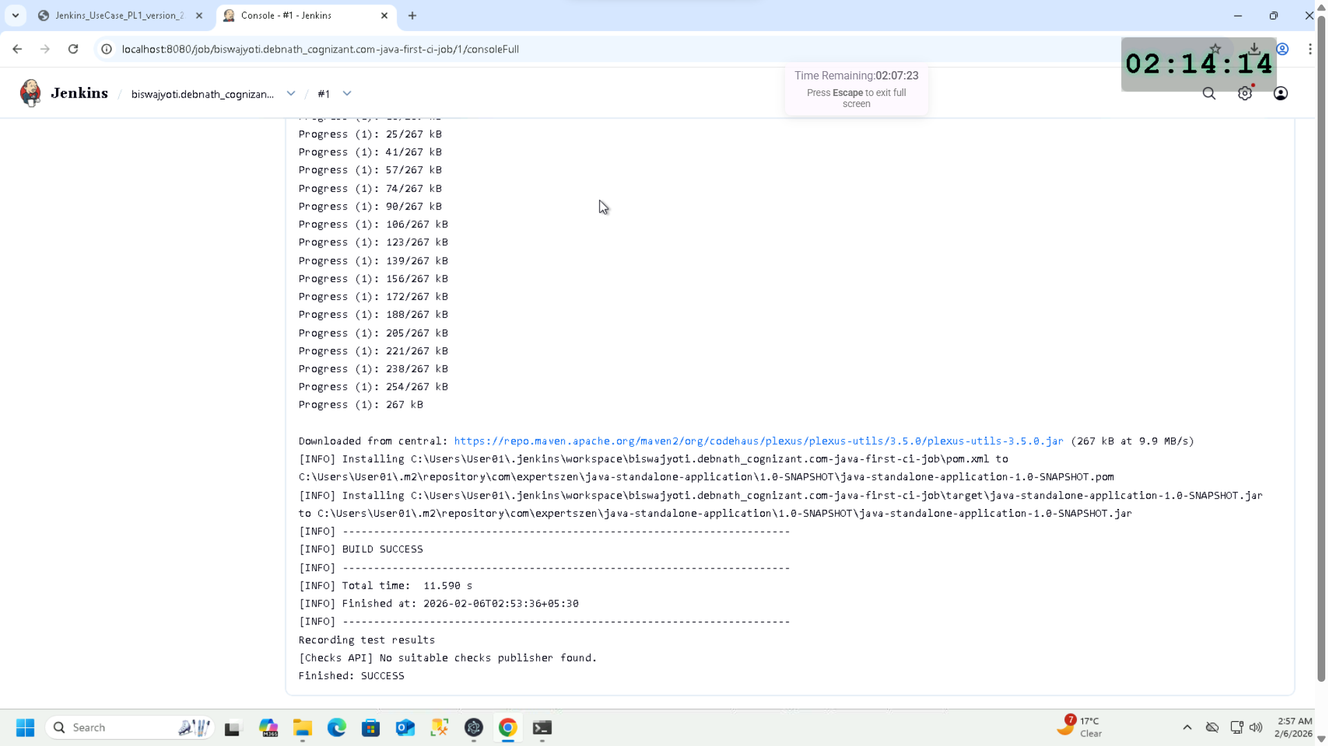

Test passed  
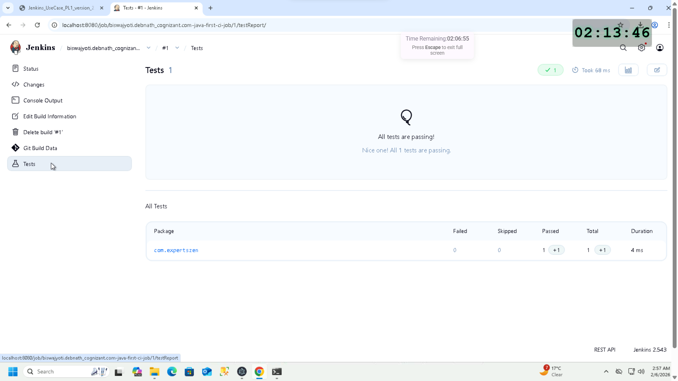  
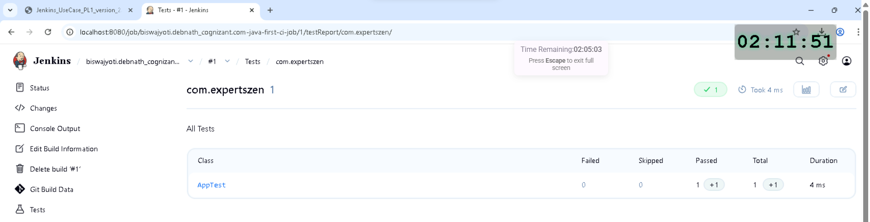  
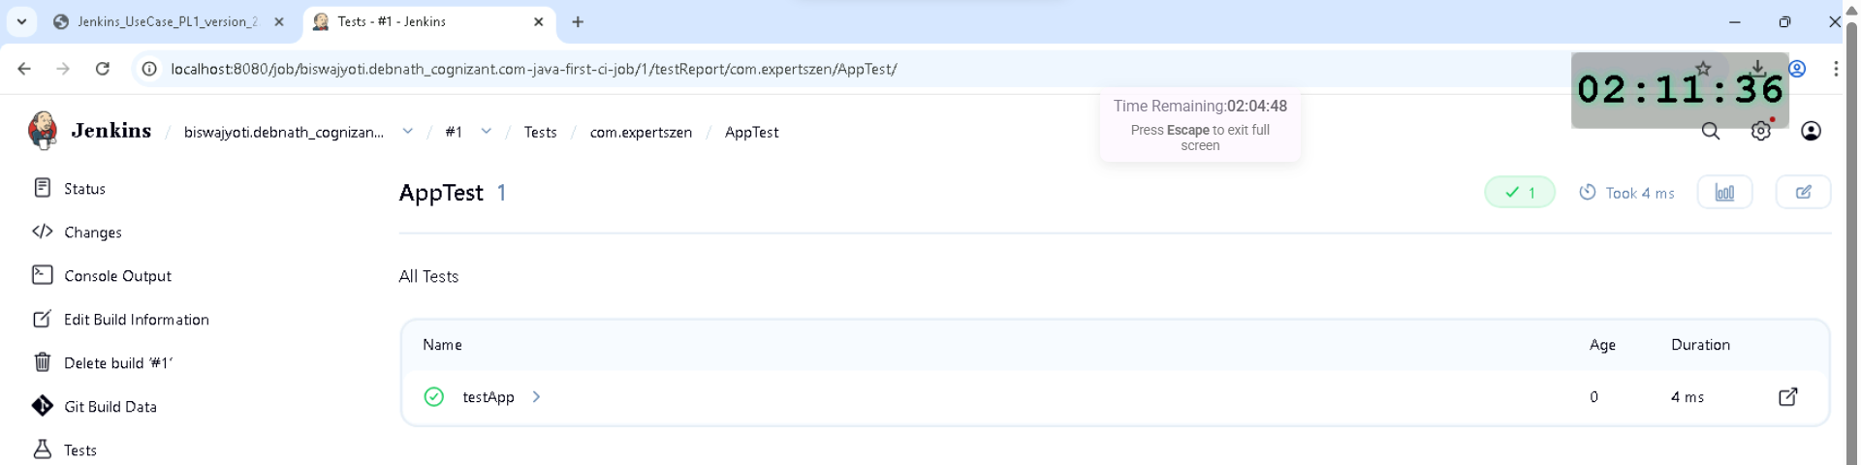

USER STORY 3

Job scheduled for every Monday 9 AM IST – cron syntax  
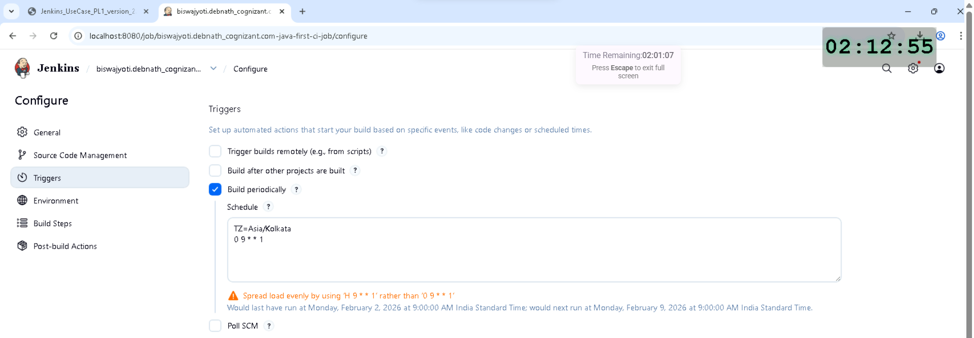

Second Job Build success  
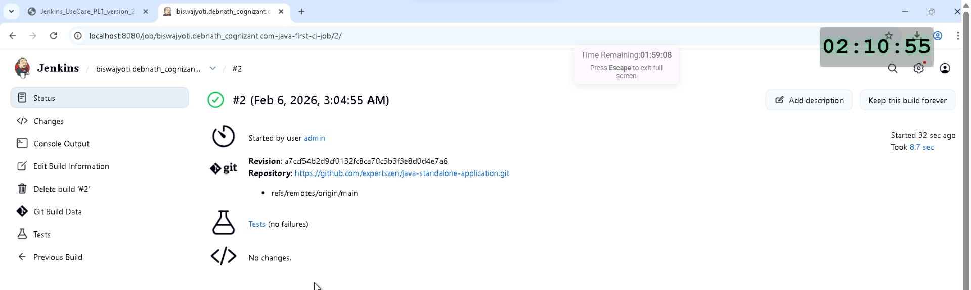

Console Output  
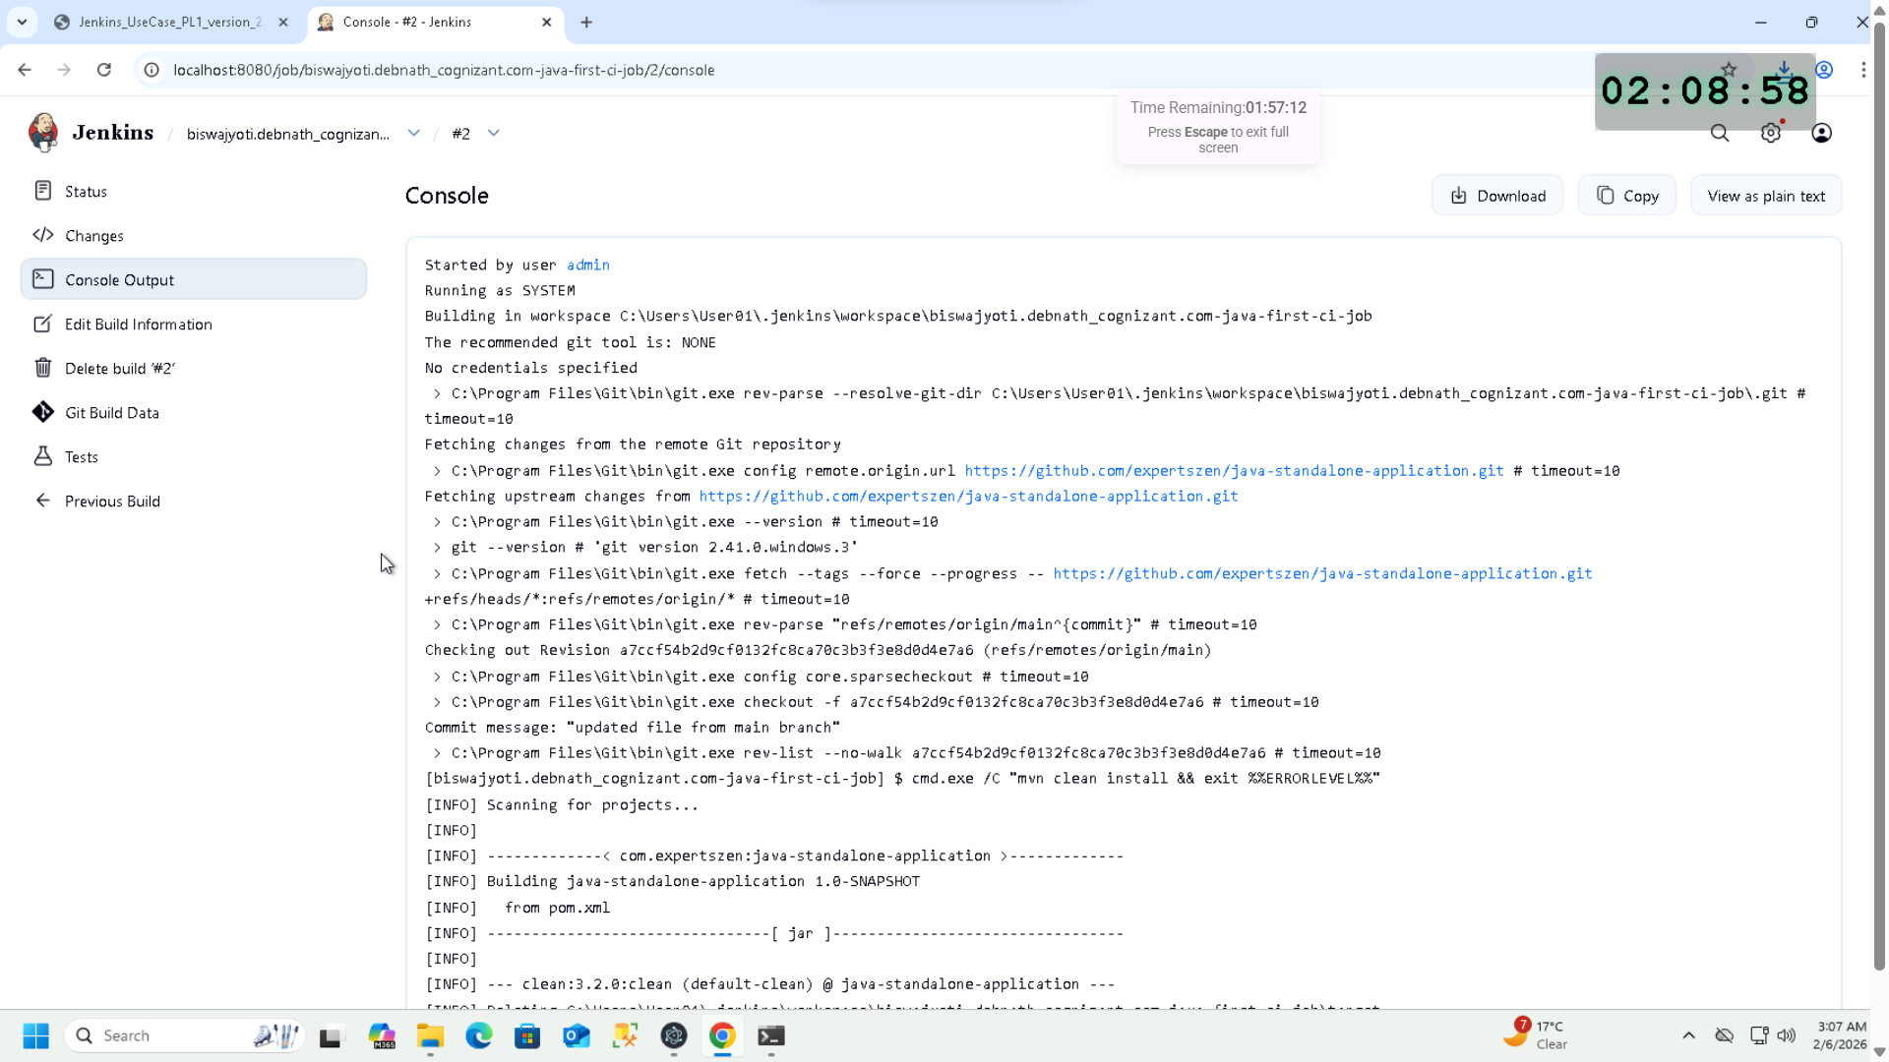  
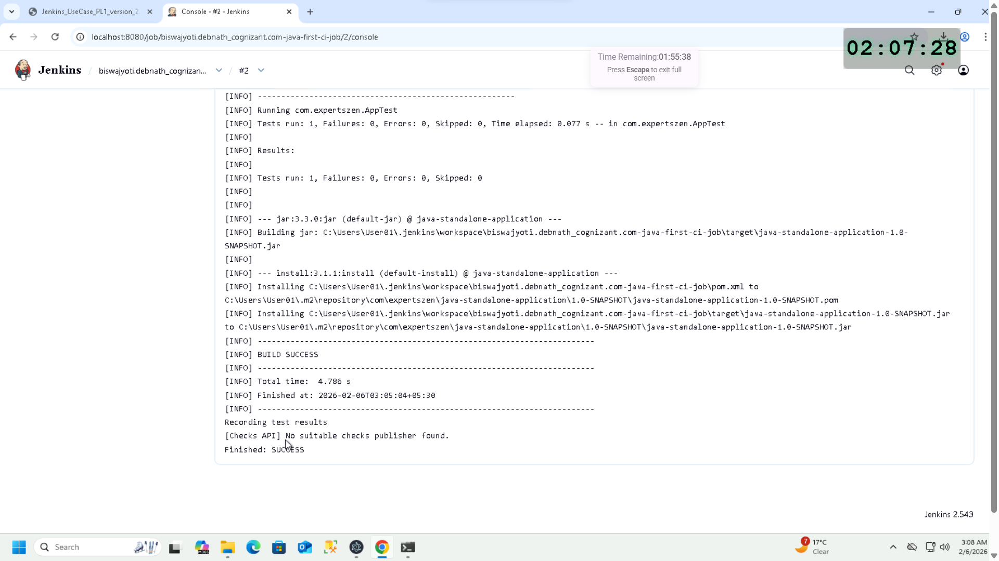

USER STORY 4

System admin email set  
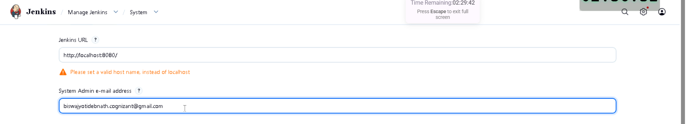

Recipient email added to job  
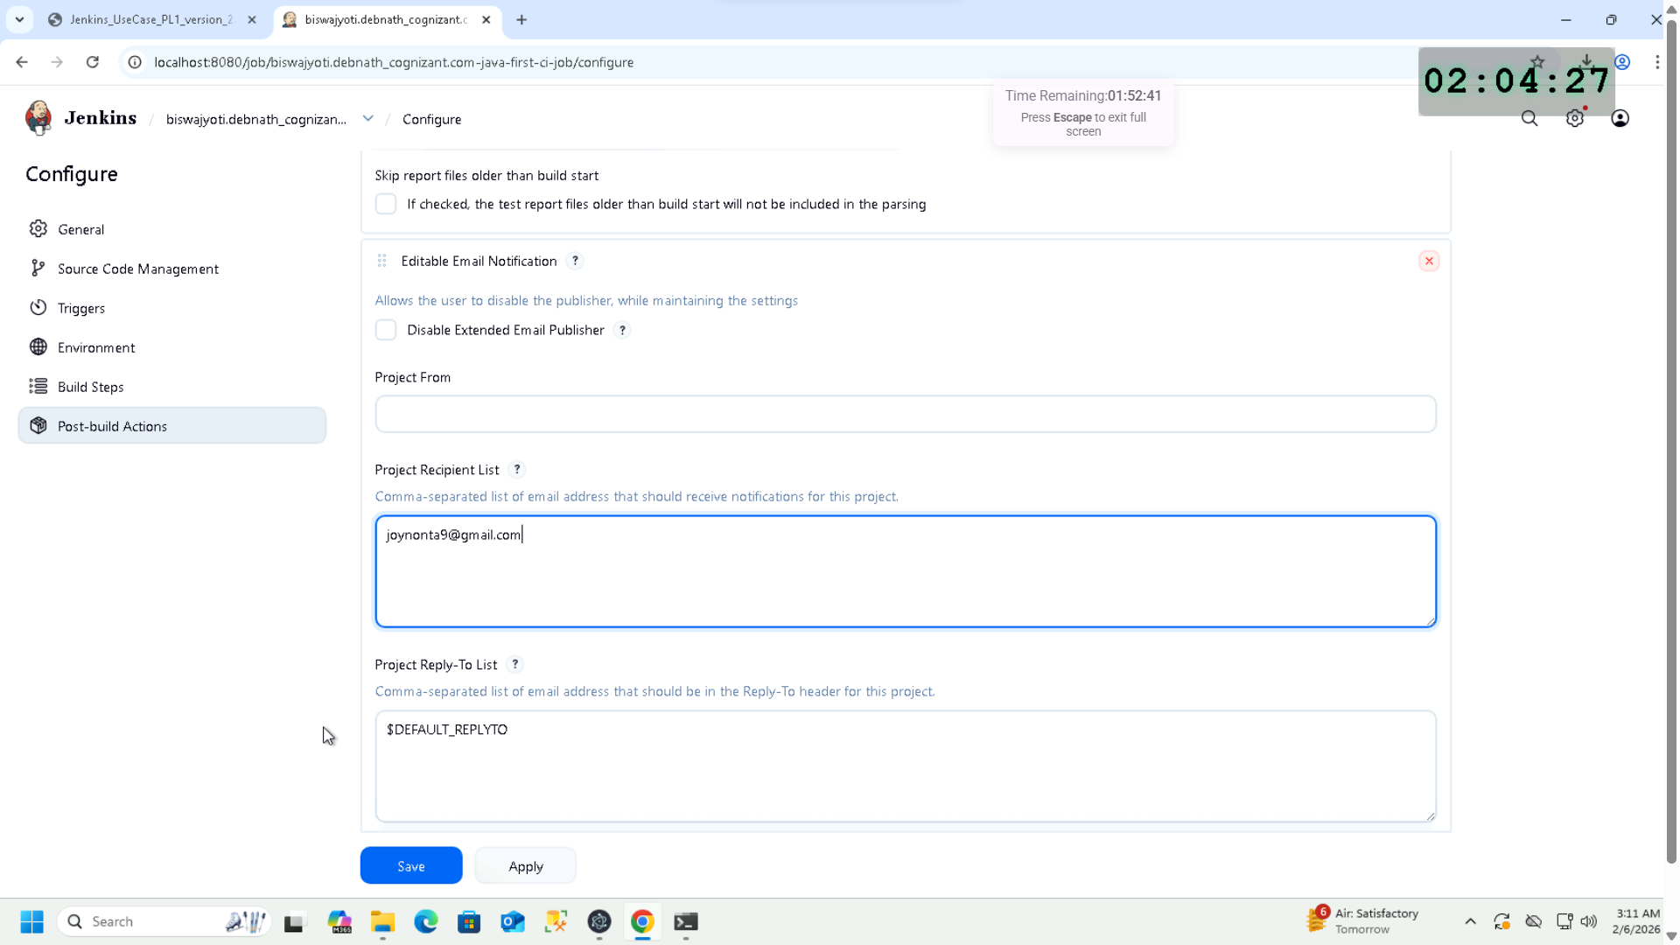

Trigger set to Always  
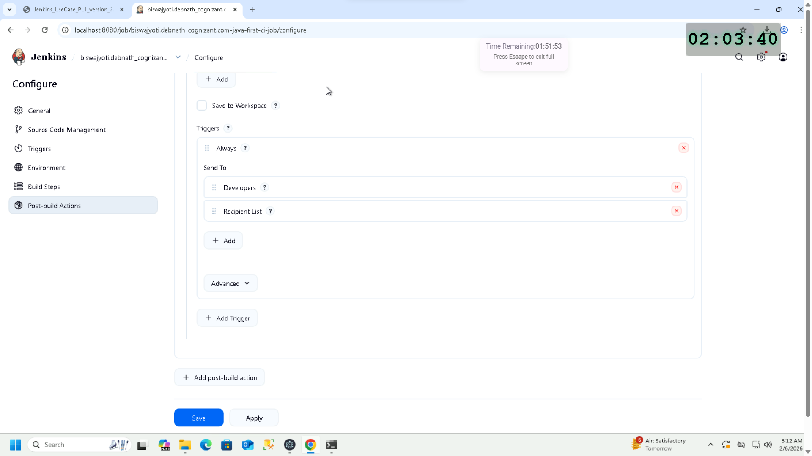

Trigger set to Success with Recipient List  
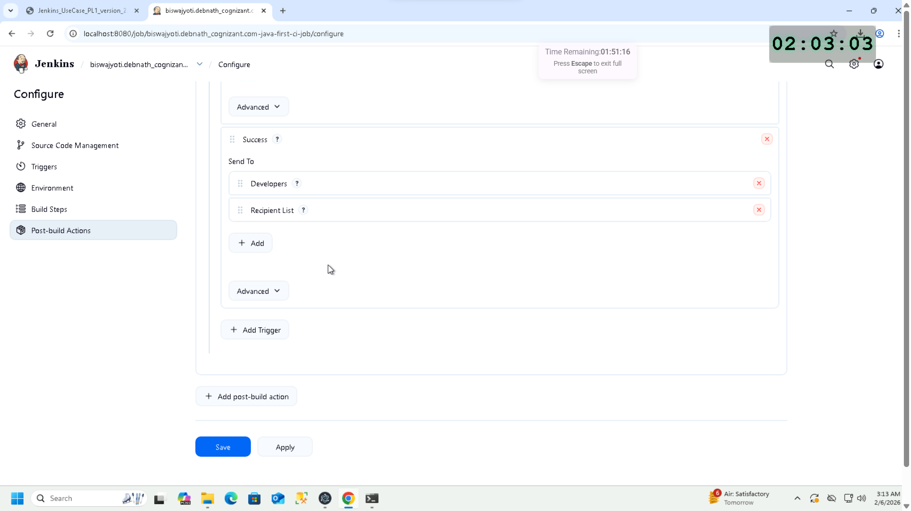

Trigger set to Failure  
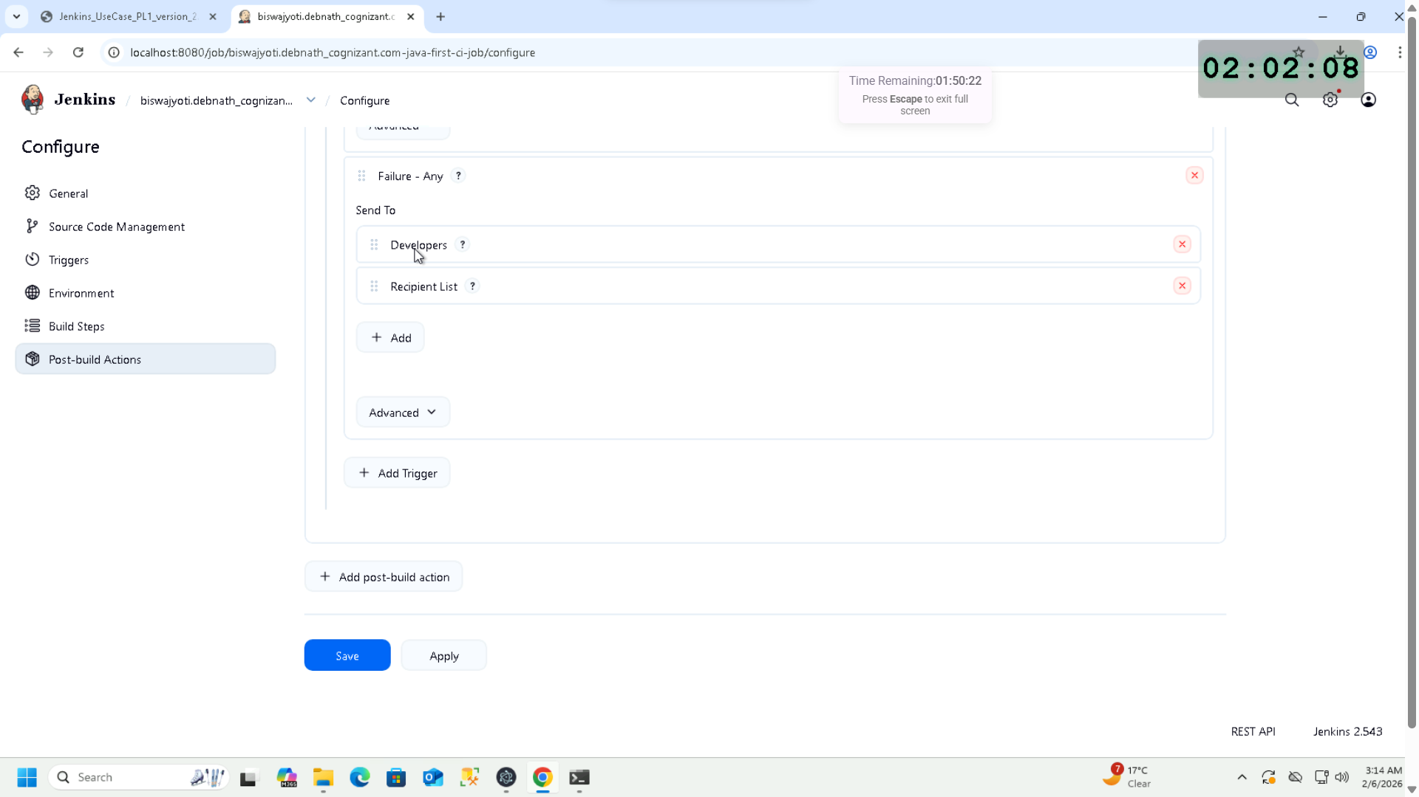

Extended email notification set  
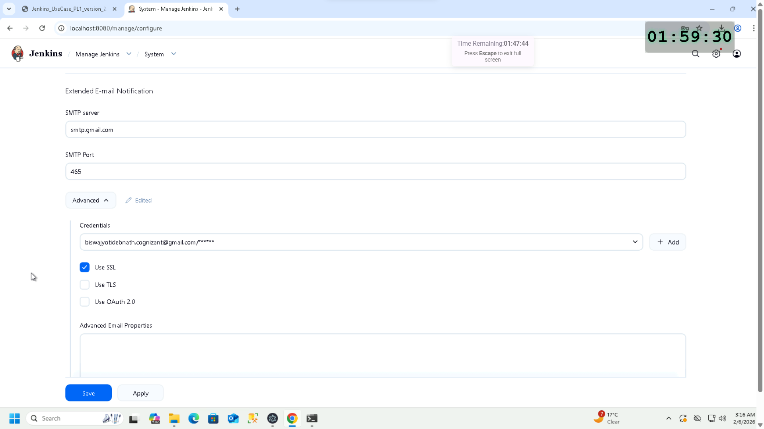

Email sent successfully upon job completion  
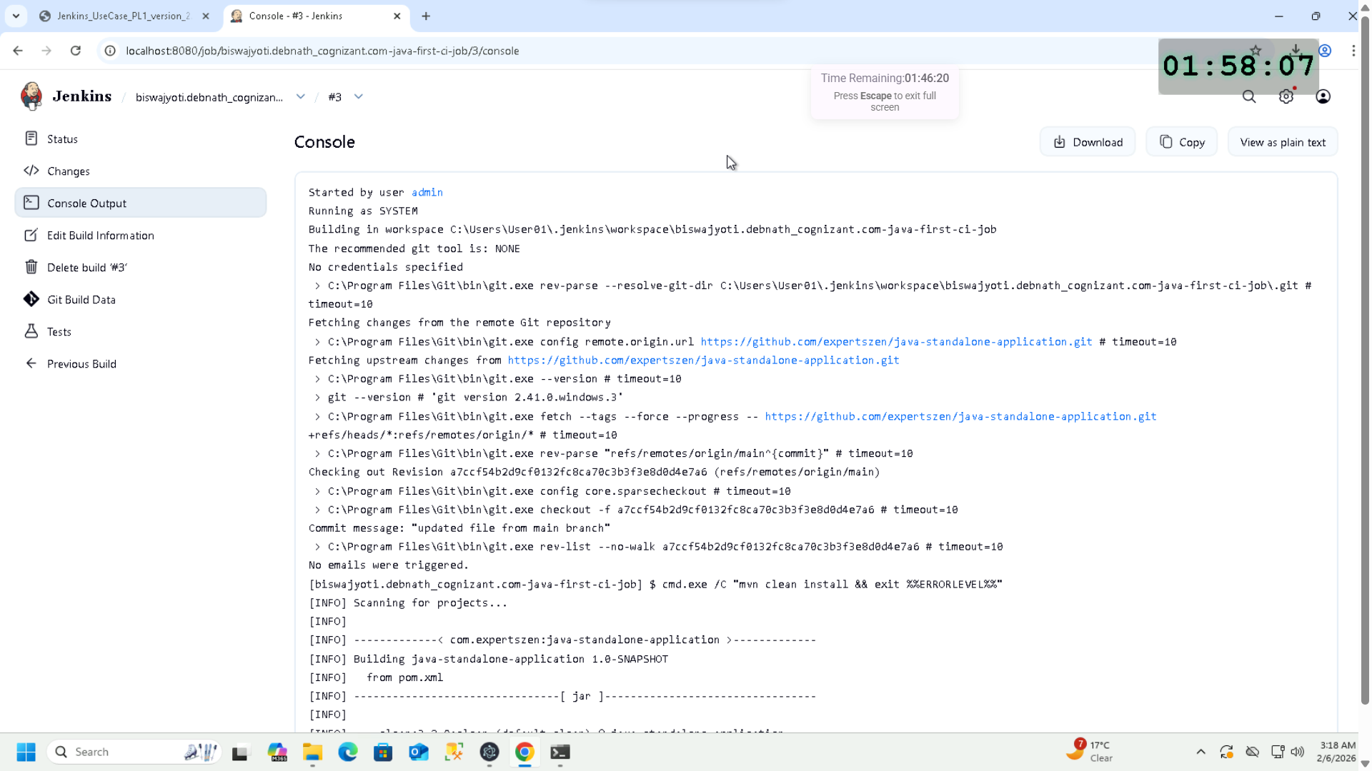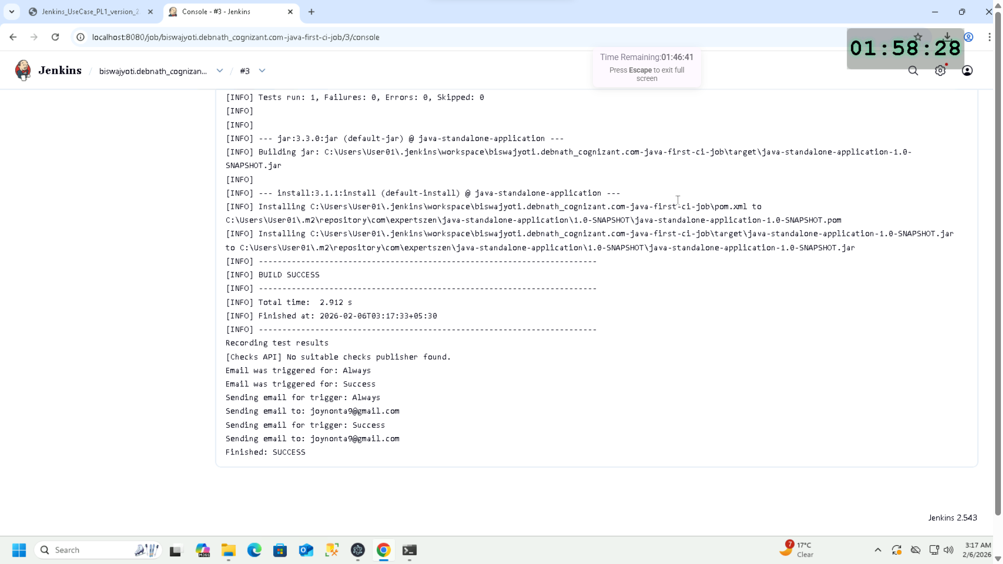

Email received  
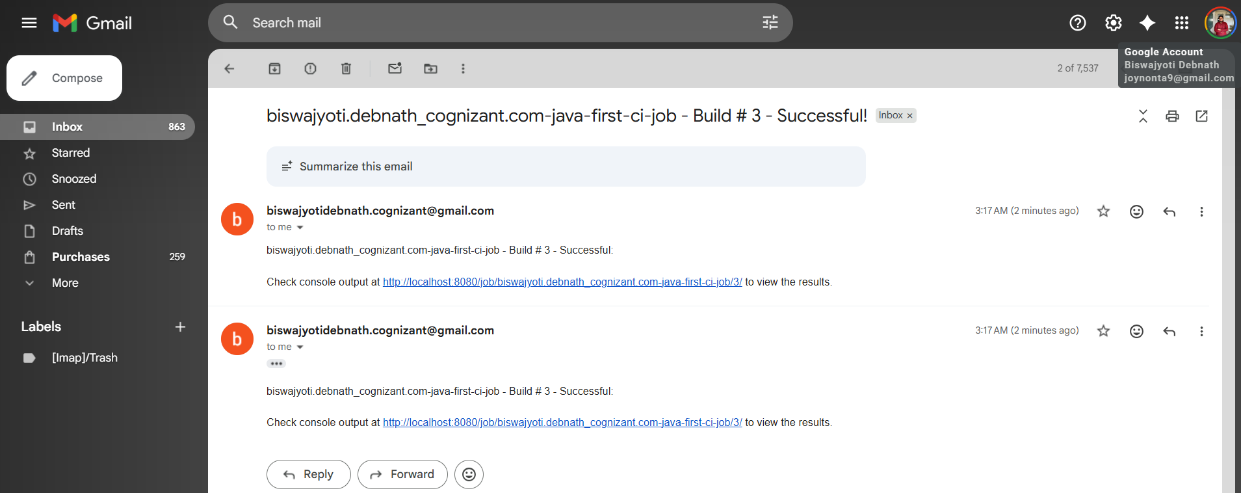

Jenkins test visualization  
